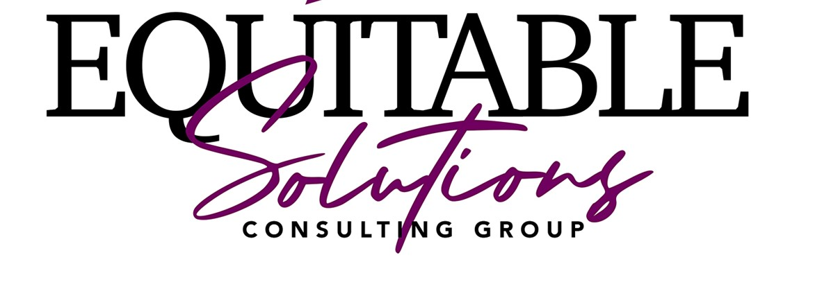

2023 Strategic Plan
[Updated 12/1/2023]

Introduction:
Equitable Solutions Behavioral Health (the Agency) is a community-based organization dedicated to filling gaps in services to the citizens of Maryland with mental health issues. Our intent is to engage in a strategic planning process every year in which a variety of input and information is analyzed.
How We develop the Strategic Plan- We gather information for our annual plan via annual online surveys of the people we serve and their families, our staff, and stakeholders. We analyze our organization’s strengths, and weaknesses and emerging opportunities and potential threats. Out of this process a strategic plan is formulated and the “critical issues” for the agency are developed and measurable goals are developed to address them.
We welcome your ideas and input as to improvements in services that we currently provide and new services that you think we should develop. Please email your suggestions to our CEO.
Our Strategic Plan will be shared, as relevant to the population served, with persons served, personnel and other stakeholders.
Mission
The mission of Equitable Solutions Behavioral Health is to render equitable health care services to children and adults by providing qualified and experienced professionals to implement individualized rehabilitation plans that support persons in meeting their desired outcomes and goals.

Philosophy & Purpose
Our Philosophy is that individuals with challenges are people first. They deserve to be treated with dignity and respect. They are full citizens of the State of Maryland.

Services
Equitable Solutions Behavioral Health provides an array of high-quality services including:
- Psychiatric Rehabilitation Program
- Substance Abuse Intensive Outpatient Services

Expectations of persons served.
Based on consumer satisfaction data, our consumers and their families desire locally based, accessible, and small to medium sized agencies, to provide evidenced based treatment. Equitable Solutions Behavioral Health will meet these criteria and desire to maintain a 85%+ satisfaction rate. Equitable Solutions Behavioral Health main office is located in Baltimore, MD. The location is excellent because the Agency is easily accessible by automobile or public transportation.

Expectations of other stakeholders. Our stakeholders include Managed Care Organizations and local clinicians. Equitable Solutions Behavioral Health stakeholders desire agencies having an array of services who are responsive to their regulatory requirements and provide measurable, quality, cost effective services. Equitable Solutions Behavioral Health meets these criteria and has a 85%+ satisfaction rate with our stakeholders.

The competitive environment. When marketing our services to managed-care companies and preferred provider organizations, we take into consideration their needs. For example: group vs. individual treatment, family vs. individual treatment, after-hours accessibility, access on weekends, use and tracking of outcome measures, and customer satisfaction.

In this age of health care reform and increased use of contracts with health maintenance organizations (HMOs), managed care organizations (MCOs) preferred provider organizations (PPOs), and other groups, the demand for behavioral health care providers continues to decline. This phenomenon, being driven by behavioral health "carve outs," has created a competitive clinical market, resulting in customer service being a critical factor. From this particular perspective, the customer identified as payor is: self-payor, Medicaid, and managed care companies. They clearly drive the large percentage of referrals within the industry

Financial Opportunities
Equitable Solutions Behavioral Health has sufficient cash flow to operate in 2023. A goal for this year will be to develop a line of credit to fund expansion, if needed. Equitable Solutions Behavioral Health must become considerably more sophisticated than our competitors in order to remain competitive. The likely future of agencies that are like Equitable Solutions Behavioral Health is that they will go out of business or be acquired in 2023-22 thus increasing Equitable Solutions Behavioral Health, Inc. market share.

In 2023 Equitable Solutions Behavioral Health will apply to provide 3rd party insurance services. If successfully implemented this will increase the revenue and profitability of the agency significantly.

Financial Threats
Recovery Assessment Contractors, Program Integrity, and other governmental auditing functions have identified MD as “low hanging fruit” and targeted it for Medicaid Over-Payments auditing. Equitable Solutions Behavioral Health must have a clear, aggressive corporate compliance program in place to meet this threat. The US Supreme Court ruled in June 2012 that CMS cannot take away funding from states that did not wish to join the Medicaid expansion called for in the Affordable Care Act.

While external auditors and the threat of recoupment for overpayment of Medicaid payments remain a threat in MD, Equitable Solutions Behavioral Health has taken positive action over the previous calendar year to remediate internal risks and vulnerabilities. The agency will continue to implement its compliance program to help identify and correct gaps in systems, policies and procedures, ensuring protection from third-party auditing firms.

Financial Needs
Equitable Solutions Behavioral Health needs to allocate money to accomplish its Information Technology and expansion goals in 2023. Specifically:
- $5,800 to become CARF accredited
- $2,000 for information technology
- $5,000 for staff training

The agency will allocate funds for a CARF Consultant to guide the agency through the accreditation process as part of the overall funds needed to become accredited.

The organizations capacities
The owner, officers and directors are knowledgeable. The agency has contracted with an experienced consultant. Staff are satisfied with Equitable Solutions Behavioral Health and dedicated to our clients. One difficulty that Equitable Solutions Behavioral Health has to overcome is recruiting and hiring qualified staff. Equitable Solutions Behavioral Health must look at recruiting and retention strategies.

The organization’s relationships with external stakeholders.
Our stakeholders include state MCO and local clinicians. In general, the agency has an excellent relationship with our referral sources and regulators.

The regulatory environment.
It is likely that in 2023 the state will require that all behavioral healthcare providers become nationally accredited. While we are confident of being accredited it is imperative, we do so.

The legislative environment.
The MD Legislature is dominated by the Democratic Party. One of its main planks expansion is health care. The turmoil and lack of a unified clear policy position in Congress will most likely impact service funding in some way. Equitable Solutions Behavioral Health will need to closely watch these dynamics.

The use of technology to support efficient and effective operations.
Equitable Solutions Behavioral Health must place an emphasis on developing its Information Technology in 2023. Specifically, the agency should focus on the following:
- Technology acquisition-The agency will update a user-friendly website and buy 2 new laptops.
- Technology maintenance-The agency will have sufficient knowledge and resources to maintain existing technology.
- Technology replacement- The agency will replace 1 desktop computers with new models.
- Develop HIPAA complaint company intranet including online training for staff.

SWOT Analysis
Purpose: Organizations establish a foundation for success through strategic planning focused on taking advantage of strengths, weaknesses, opportunities, and threats.

The agency has identified the following during its SWOT exercise:
Strengths  Client Focused  Resilient  Philosophical Framework  Cares for Staff  Promotes Personal Growth  Community Involvement | Weaknesses  Recruiting qualified clinicians
Threats  Competition | Opportunities  Other Agencies going out of business

Specific strategic initiatives to continuously develop, strengthen, and improve services offered by Equitable Solutions Behavioral Health in 2023-24.

Priority | Goal | Resources needed | Measure | Cost | Who | By When | Status as of 12/2023
Top | Become CARF accredited and licensed to provide behavioral healthcare services. | Contract with CARF consultant  CARF Fees | Successfully accredited and licensed | $2,500 | CEO | 12/15/23 | Site survey is sched-uled
High | Technology acquisition-  The agency will update a user-friendly website  The agency will buy 2 new laptops. | Online ordering from Dell business systems.  Update website terms and agreement. | 85% of staff, persons served and stakeholder will report the website as being user friendly.  Purchase of 2 laptops | $ / year for domain hosting  $ / year for domain name.  ~$ 1000 /year ongoing support by webmaster.  ~$400 for laptop | CEO |  | In process
Moderate | Technology replacement-  The agency will replace 2 desktop computers with new models | Online ordering from Dell business systems. | Replacement of 2 desktop computers |  | CEO |  | In Progress
High | Develop HIPAA complaint company intranet including online training for staff. | Contract with training consultant. | Successful development of online training.  Training records audit will show 100% compliance with requirements |  | CEO |  | Still in search of consultant.
High | To improve the efficiency of the Intensive In Home services, IOP Substance Use, Psychiatric Rehabilitation programs the agency will have wait times from referral to first day of service with an average of 14 days. | Education of staff | The agency EHR will be mined for data to calculate wait times. | ~1% of revenue ( to use EHR) | CEO | 12/1/23 | Completed  The average wait time is 14 days .
High | Persons served and stakeholders will report high levels of satisfaction with IOP Substance Use, Psychiatric Rehabilitation programs. | Develop satisfaction surveys for persons served and stakeholders | 85% of survey respondents will report being satisfied or very satisfied on the 2023 satisfaction surveys | $ / years for survey software | CEO | 12/31/23 | In process

